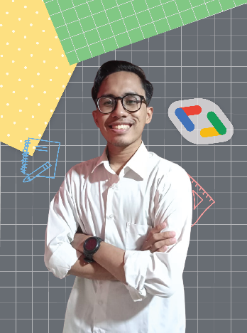FACHRIDAN TIO MU’AFA (FACHRI)

**Email Address :** [fachridantm@gmail.com](mailto:fachridantm@gmail.com)

**LinkedIn :** [linkedin.com/in/fachridantm/](https://www.linkedin.com/in/fachridantm/)

**Instagram :** [**instagram.com/fachridantm/**](https://www.instagram.com/fachridantm)

PERSONAL DATA

* **Place, Date of Birth** : Jakarta, May 17th 2001
* **Marital Status** : Single

# EDUCATION

## Bangkit Academy led by Google, GoTo, Traveloka (Jan 2022 – Jul 2022)

### Mobile Development (Android)

## Android Developer Club led by HIMTI DEV (Mar 2021 – Jan 2022)

### Member (Awardee as Best Member)

## **Universitas Islam Negeri Syarif Hidayatullah Jakarta** (Sep 2019 – Present)

### Teknik Informatika

## Pondok Pesantren Al Hamid (2013 – 2019)

# ORGANIZATIONAL EXPERIENCE

## Google Developer Student Clubs UIN Jakarta (Aug 2021 – Jul 2022)

### Lead

## Himpunan Mahasiswa Teknik Informatika UIN Jakarta (Jan 2021 – Jan 2022)

### Staff Divisi Kaderisasi dan Advokasi

# VOLUNTEER EXPERIENCE

## **Google I/O Extended Jakarta**

##### GDG Jakarta

## GDSC Talk Series: Indonesia

##### GDSC Indonesia

## Discord Manager

### Google Developers Community: Indonesia